1.ReactJS
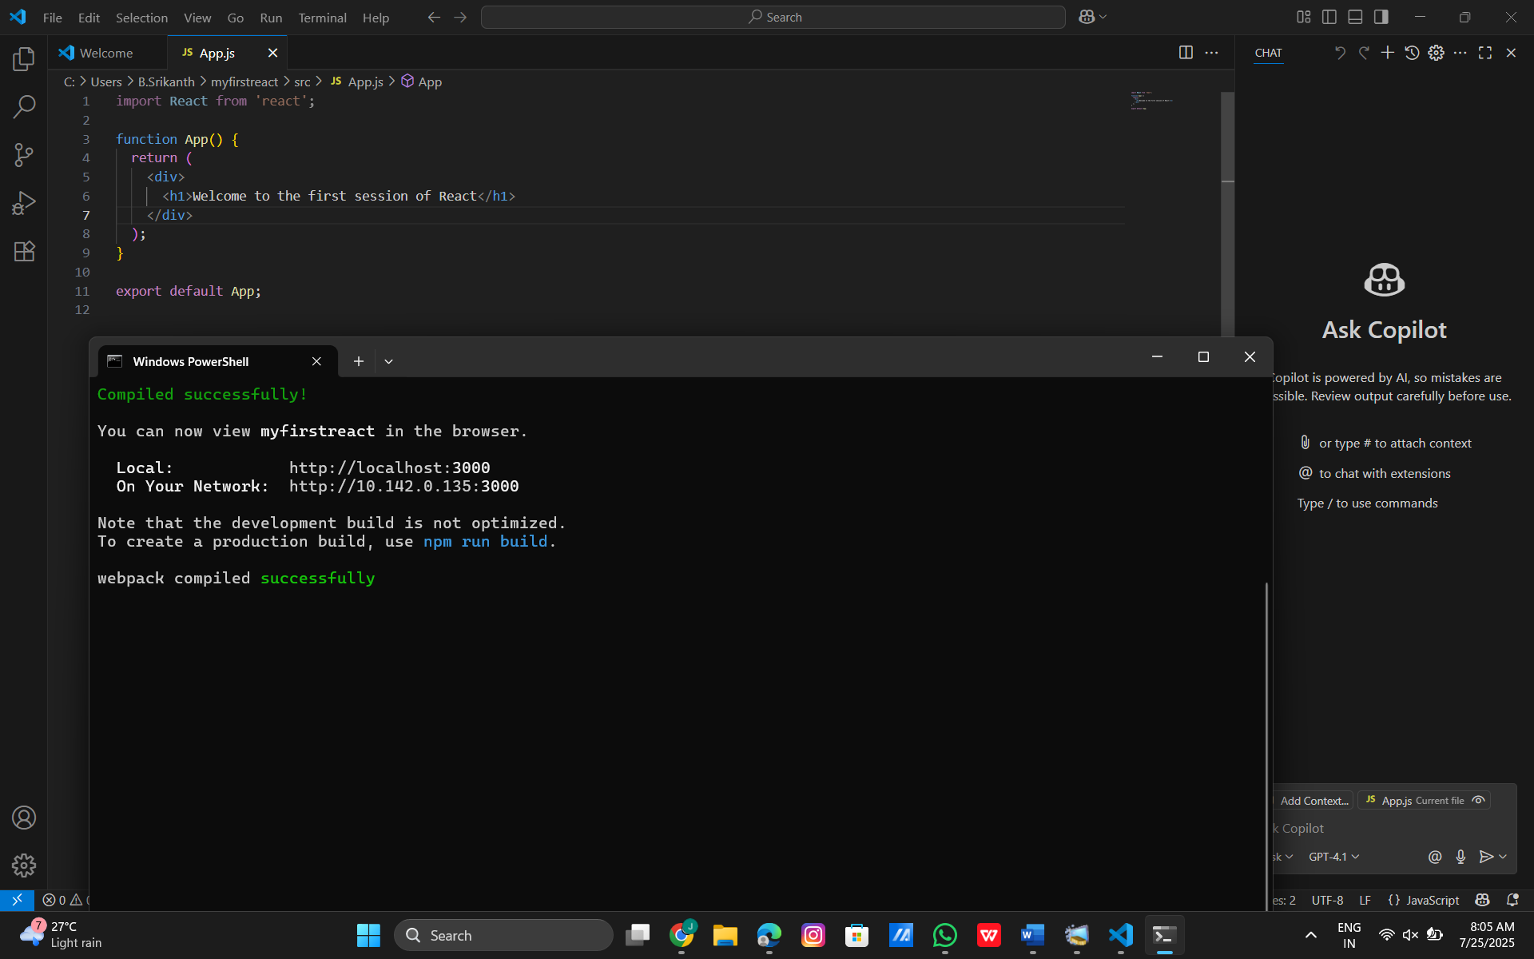
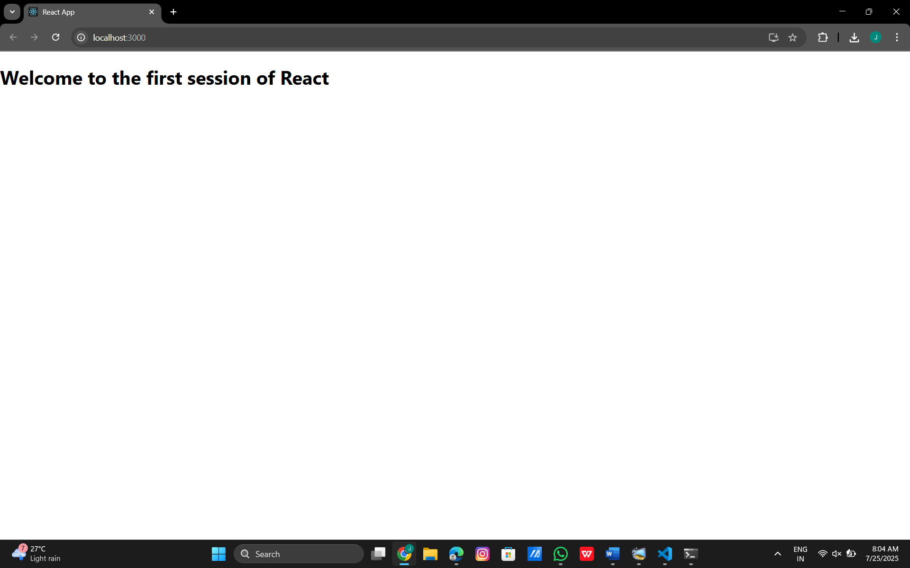
Hence ,executed the React application.

2.ReactJS
Home.js:
import React, { Component } from 'react';
class Home extends Component {
render() {
return (
<div>
<h1>Welcome to the Home page of Student Management Portal</h1>
</div>
);
}
}
export default Home;
About.js:
import React, { Component } from 'react';
class About extends Component {
render() {
return (
<div>
<h1>Welcome to the About page of Student Management Portal</h1>
</div>
);
}
}
export default About;
Contact.js:
import React, { Component } from 'react';
class Contact extends Component {
render() {
return (
<div>
<h1>Welcome to the Contact page of Student Management Portal</h1>
</div>
);
}
}
export default Contact;

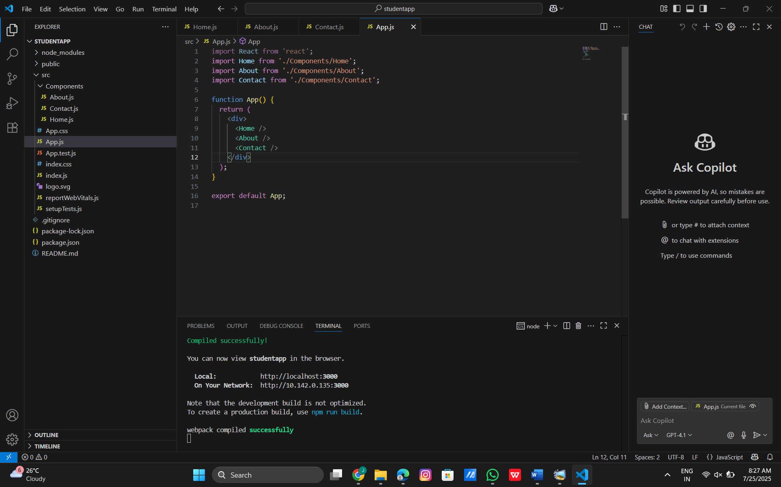


3. ReactJS
CalculateScore.js:
import './Stylesheets/mystyle.css'
const percentToDecimal = (decimal) => {
return (decimal.toFixed(2) + '%')
}
const calcScore = (total, goal) => {
return percentToDecimal(total / goal)
}
export const CalculateScore = ({ Name, School, total, goal }) => (
<div className="formatstyle">
<h1><font color="Brown">Student Details:</font></h1>
<div className="Name">
<b><span> Name: </span></b>
<span>{Name}</span>
</div>
<div className="School">
<b><span> School: </span></b>
<span>{School}</span>
</div>
<div className="Total">
<b><span>Total:</span></b>
<span>{total}</span>
<span> Marks</span>
</div>
<div className="Score">
<b>Score:</b>
<span>
{calcScore(
total,
goal
)}
</span>
</div>
</div>
)
Mystyle.css:
.Name {
font-weight: 300;
color: blue;
}
.School {
color: crimson;
}
.Total {
color: darkmagenta;
}
.formatstyle {
text-align: center;
font-size: large;
}
.Score {
color: forestgreen;
}
App.js:
import React from 'react';
import './App.css';
import { CalculateScore } from './Components/CalculateScore';
function App() {
return (
<div className="App">
<CalculateScore
Name={"Steeve"}
School={"DNV Public School"}
total={284}
goal={3}
/>
</div>
);
}
export default App;
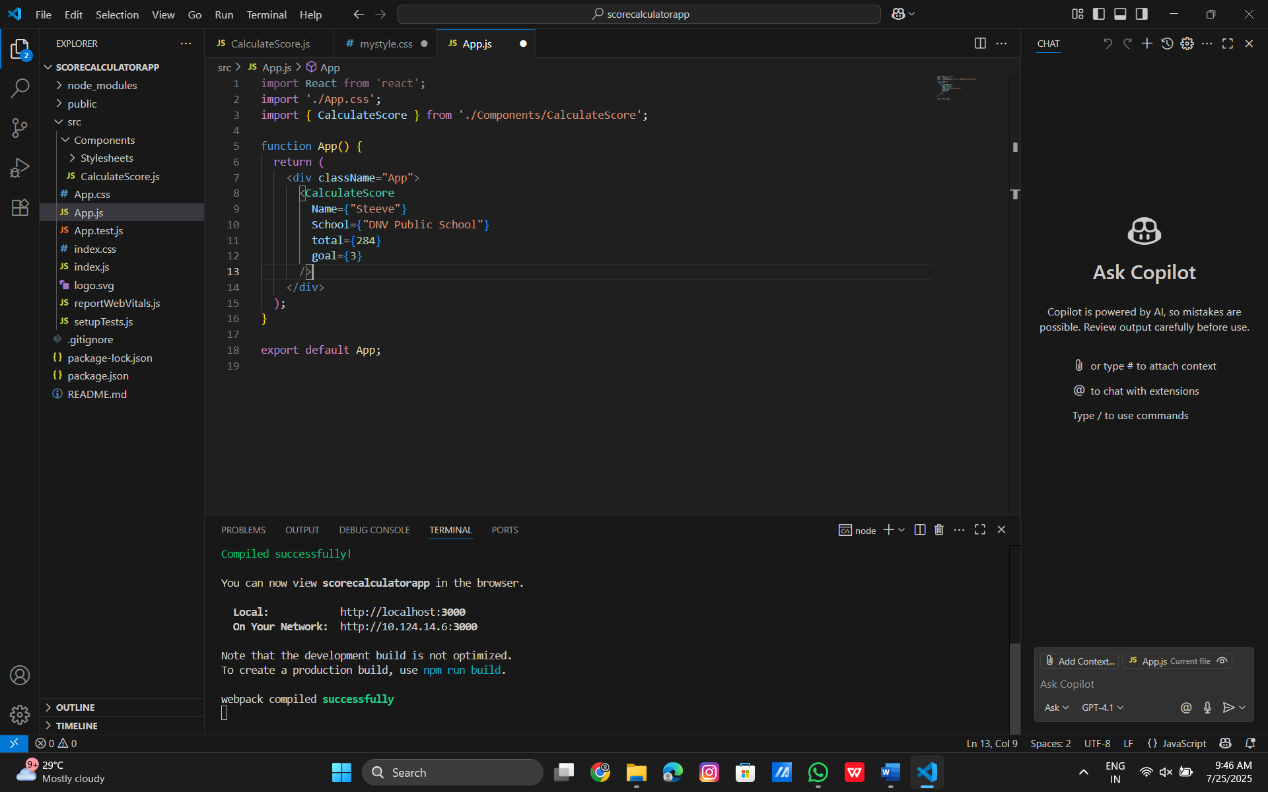

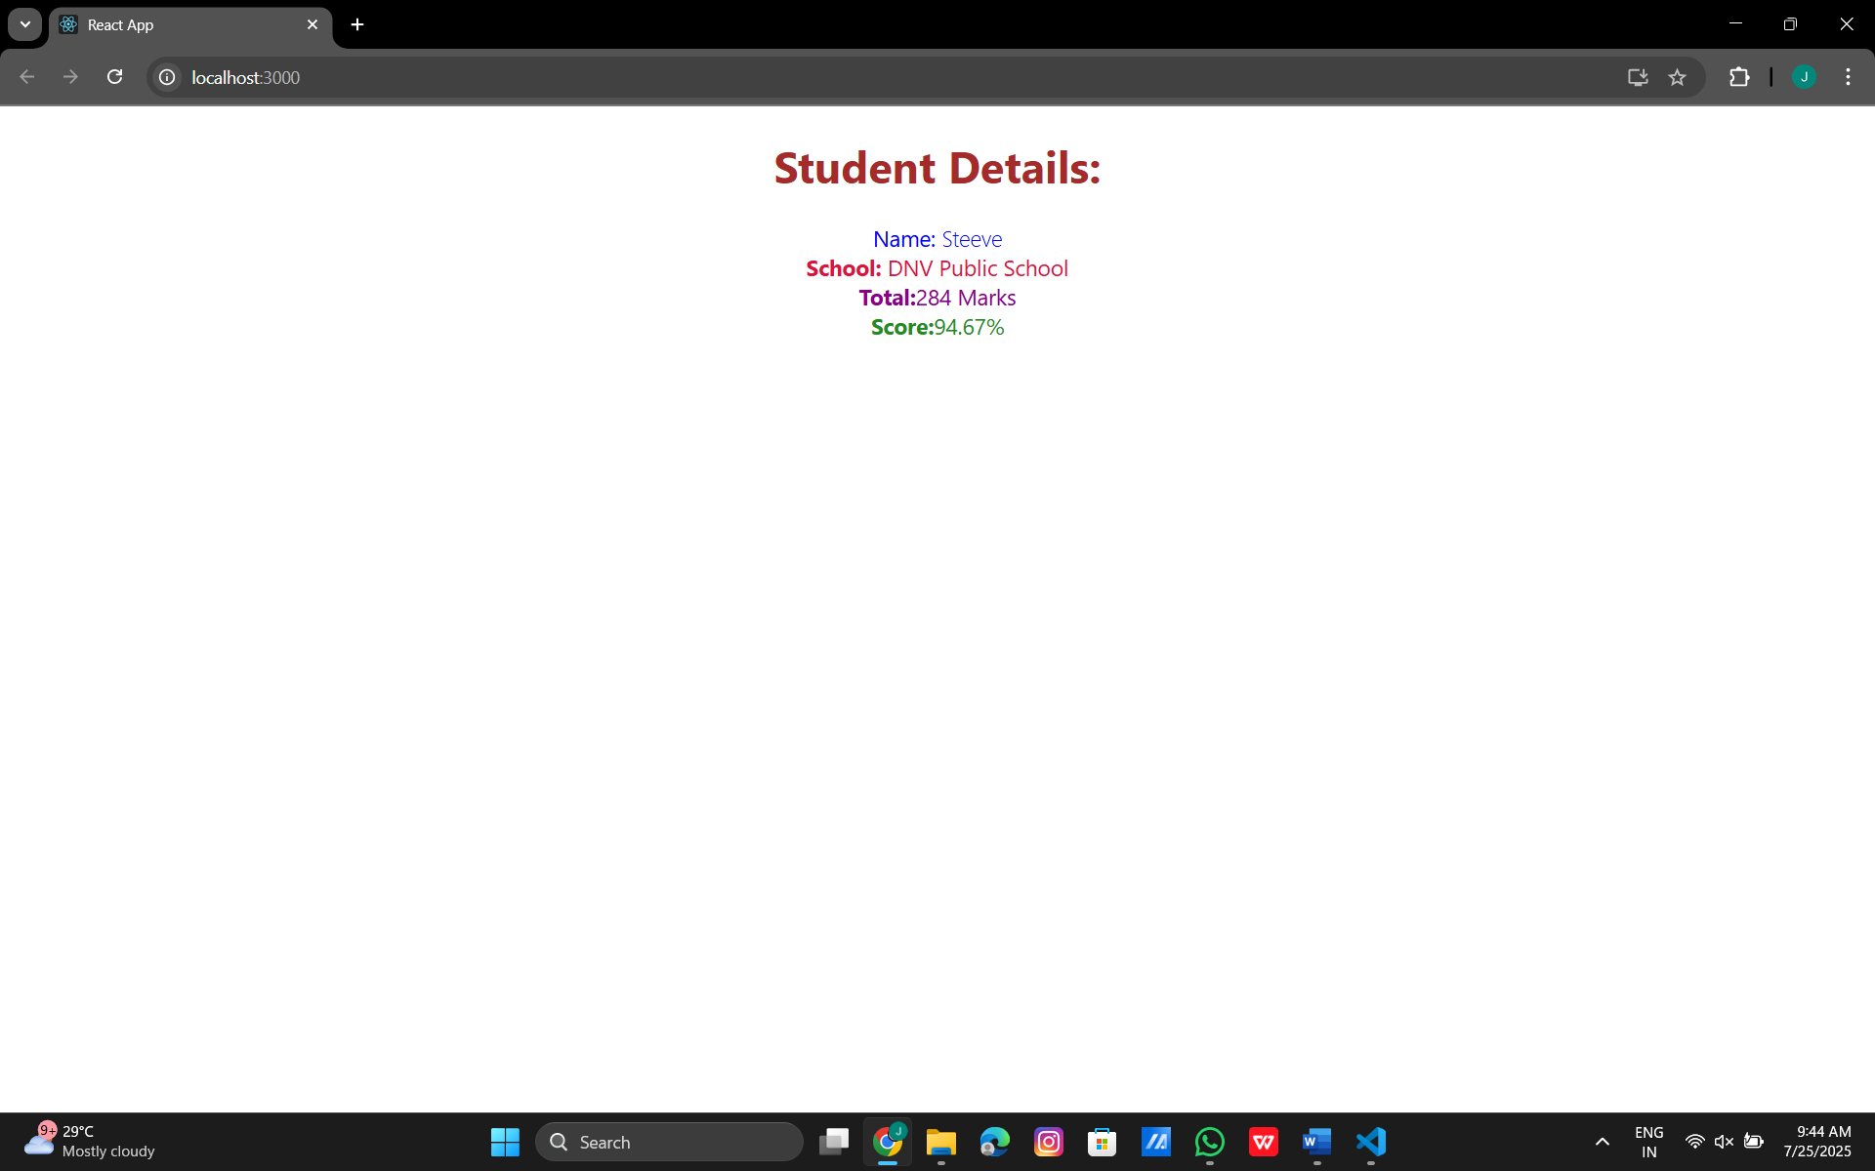

4.ReactJS
Post.js:
import React from "react";
import "./Post.css"; // optional if you add custom styling
class Post extends React.Component {
render() {
return (
<div className="Post">
<h3>{this.props.title}</h3>
<p>{this.props.body}</p>
</div>
);
}
}
export default Post;
Posts.js:
import React from "react";
import Post from "./Post";
class Posts extends React.Component {
constructor(props) {
super(props);
this.state = {
posts: []
};
}
loadPosts = () => {
fetch("https://jsonplaceholder.typicode.com/posts")
.then((res) => res.json())
.then((data) => this.setState({ posts: data.slice(0, 10) })) // Only first 10 posts
.catch((error) => console.error("Error fetching posts:", error));
};
componentDidMount() {
this.loadPosts();
}
componentDidCatch(error, info) {
alert("An error occurred: " + error);
}
render() {
return (
<div>
<h2>Posts</h2>
{this.state.posts.map((post) => (
<Post key={post.id} title={post.title} body={post.body} />
))}
</div>
);
}
}
export default Posts;
App.js:
import React, { useState } from "react";
import Posts from "./Posts";
import "./App.css";
function App() {
const [darkMode, setDarkMode] = useState(false);
const toggleTheme = () => {
setDarkMode(!darkMode);
};
return (
<div className={`App ${darkMode ? "dark" : "light"}`}>
<button className="theme-toggle" onClick={toggleTheme}>
Switch to {darkMode ? "Light" : "Dark"} Mode
</button>
<h1>Blog App</h1>
<Posts />
</div>
);
}
export default App;
App.css:
body {
margin: 0;
padding: 0;
font-family: Arial, sans-serif;
}
.App {
padding: 20px;
transition: all 0.3s ease;
}
.App.light {
background-color: #f9f9f9;
color: #222;
}
.App.dark {
background-color: #121212;
color: #eee;
}
h1 {
text-align: center;
margin-bottom: 40px;
}
.theme-toggle {
position: absolute;
top: 20px;
right: 20px;
padding: 8px 14px;
background-color: #007acc;
color: white;
border: none;
border-radius: 6px;
cursor: pointer;
transition: 0.3s ease;
}
.theme-toggle:hover {
background-color: #005fa3;
}
Post.css:
.Post {
background-color: inherit;
border: 1px solid #444;
border-radius: 8px;
padding: 16px;
margin-bottom: 20px;
box-shadow: 0 1px 3px rgba(0, 0, 0, 0.1);
}
.Post h3 {
color: inherit;
margin: 0 0 10px 0;
}
.Post p {
font-size: 16px;
line-height: 1.5;
color: inherit;
}

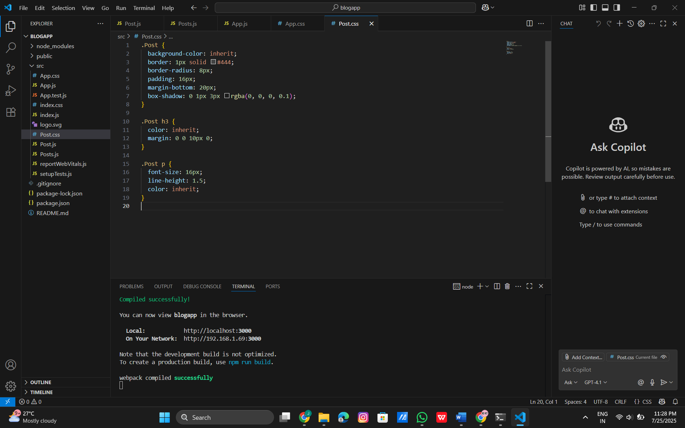
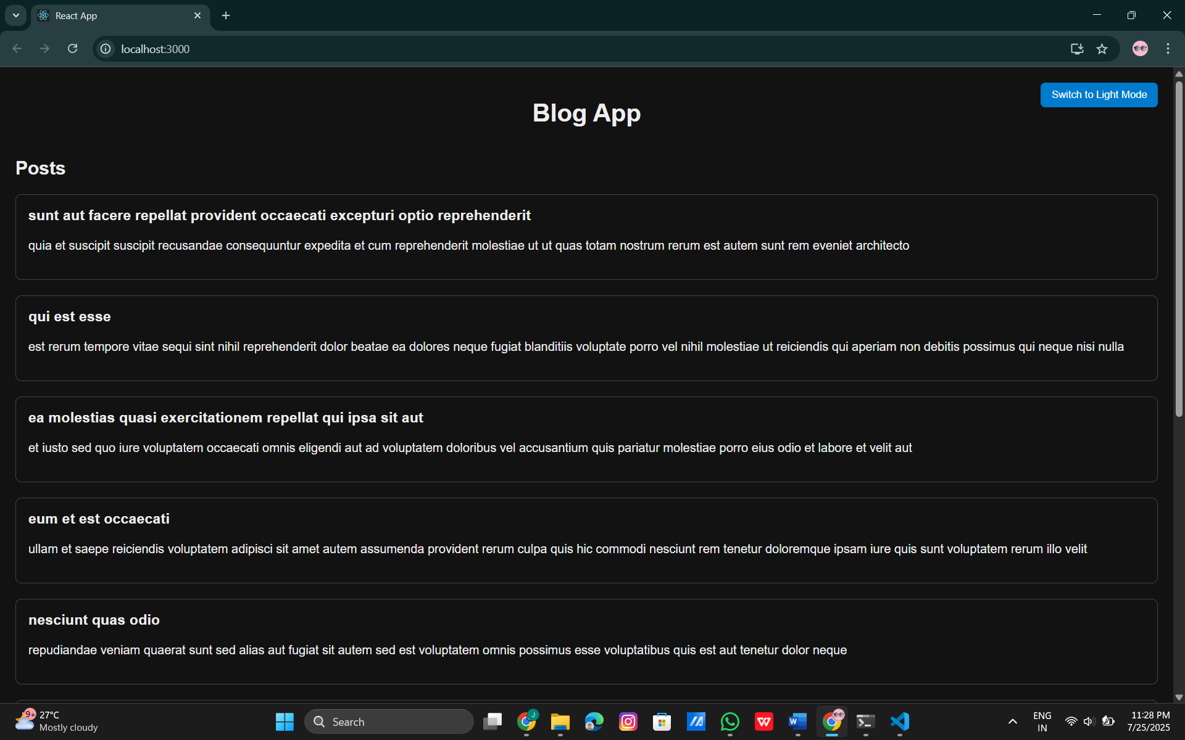

5.ReactJS
CohortDetails.module.css:
.box {
width: 300px;
display: inline-block;
margin: 10px;
padding: 10px 20px;
border: 1px solid black;
border-radius: 10px;
}
dt {
font-weight: 500;
}
App.js:
import React from 'react';
import CohortDetails from './CohortDetails';
function App() {
const cohortData = [
{
cohortCode: "INTADMDF10",
technology: ".NET FSD",
startDate: "22-Feb-2022",
currentStatus: "Scheduled",
coachName: "Aathma",
trainerName: "Jojo Jose"
},
{
cohortCode: "ADM21JF014",
technology: "Java FSD",
startDate: "10-Sep-2021",
currentStatus: "Ongoing",
coachName: "Apoorv",
trainerName: "Elisa Smith"
},
];
return (
<div>
<h2>Cohorts Details</h2>
{cohortData.map((cohort, index) => (
<CohortDetails key={index} cohort={cohort} />
))}
</div>
);
}
export default App;

CohortDetails.js:

import styles from './CohortDetails.module.css';
function CohortDetails(props) {
return (
<div className={styles.box}>
<h3 style={{ color: props.cohort.currentStatus === 'Ongoing' ? 'green' : 'blue' }}>
{props.cohort.cohortCode} -
<span>{props.cohort.technology}</span>
</h3>
<dl>
<dt>Started On</dt>
<dd>{props.cohort.startDate}</dd>
<dt>Current Status</dt>
<dd>{props.cohort.currentStatus}</dd>
<dt>Coach</dt>
<dd>{props.cohort.coachName}</dd>
<dt>Trainer</dt>
<dd>{props.cohort.trainerName}</dd>
</dl>
</div>
);
}
export default CohortDetails;
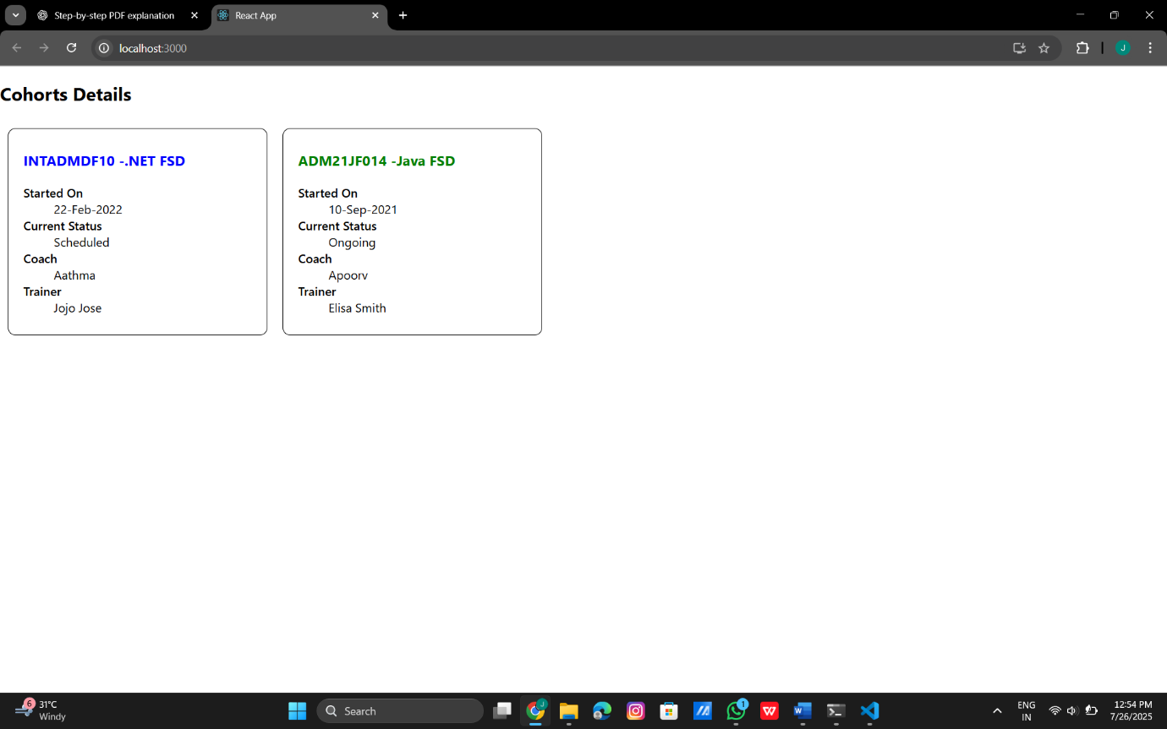

6.ReactJS
Trainer.js:
export class Trainer {
constructor(trainerId, name, email, phone, technology, skills) {
this.trainerId = trainerId;
this.name = name;
this.email = email;
this.phone = phone;
this.technology = technology;
this.skills = skills;
}
}
TrainersMock.js:
import { Trainer } from './Trainer';
export const trainers = [
new Trainer(1, "John Doe", "john@example.com", "1234567890", "React", ["JavaScript", "Redux"]),
new Trainer(2, "Jane Smith", "jane@example.com", "9876543210", "Angular", ["TypeScript", "RxJS"]),
new Trainer(3, "Alan Watts", "alan@example.com", "1112223333", "Vue", ["Vuex", "Composition API"]),
];
Home.js:
import React from 'react';
function Home() {
return (
<div>
<h2>Welcome to TrainersApp</h2>
<p>This app shows a list of trainers with details using React Router.</p>
</div>
);
}
export default Home;
TrainersList.js:
import React from 'react';
import { Link } from 'react-router-dom';
function TrainersList({ data = [] }) {
if (!data || data.length === 0) {
return (
<div>
<h2>Trainers List</h2>
<p>No trainers found.</p>
</div>
);
}
return (
<div>
<h2>Trainers List</h2>
<ul>
{data.map((trainer) => (
<li key={trainer.trainerId}>
<Link to={`/trainer/${trainer.trainerId}`}>{trainer.name}</Link>
</li>
))}
</ul>
</div>
);
}
export default TrainersList;
TrainerDetail.js:
import React from 'react';
import { useParams } from 'react-router-dom';
import { trainers } from './TrainersMock';
function TrainerDetail() {
const { id } = useParams(); // URL param from route
const trainerId = parseInt(id); // Convert string to number
const trainer = trainers.find((t) => t.trainerId === trainerId);
if (!trainer) {
return <p>Trainer not found!</p>;
}
return (
<div>
<h2>Trainer Details</h2>
<p><strong>ID:</strong> {trainer.trainerId}</p>
<p><strong>Name:</strong> {trainer.name}</p>
<p><strong>Email:</strong> {trainer.email}</p>
<p><strong>Phone:</strong> {trainer.phone}</p>
<p><strong>Technology:</strong> {trainer.technology}</p>
<p><strong>Skills:</strong> {trainer.skills.join(', ')}</p>
</div>
);
}
export default TrainerDetail;

App.js:
import React from 'react';
import { BrowserRouter, Routes, Route, Link } from 'react-router-dom';
import Home from './Home';
import TrainersList from './TrainersList';
import TrainerDetail from './TrainerDetail';
import { trainers } from './TrainersMock';
function App() {
return (
<BrowserRouter>
<div>
<nav>
<Link to="/">Home</Link> | <Link to="/trainers">Trainers</Link>
</nav>
<hr />
<Routes>
<Route path="/" element={<Home />} />
<Route path="/trainers" element={<TrainersList data={trainers} />} />
<Route path="/trainer/:id" element={<TrainerDetail />} />
</Routes>
</div>
</BrowserRouter>
);
}
export default App;
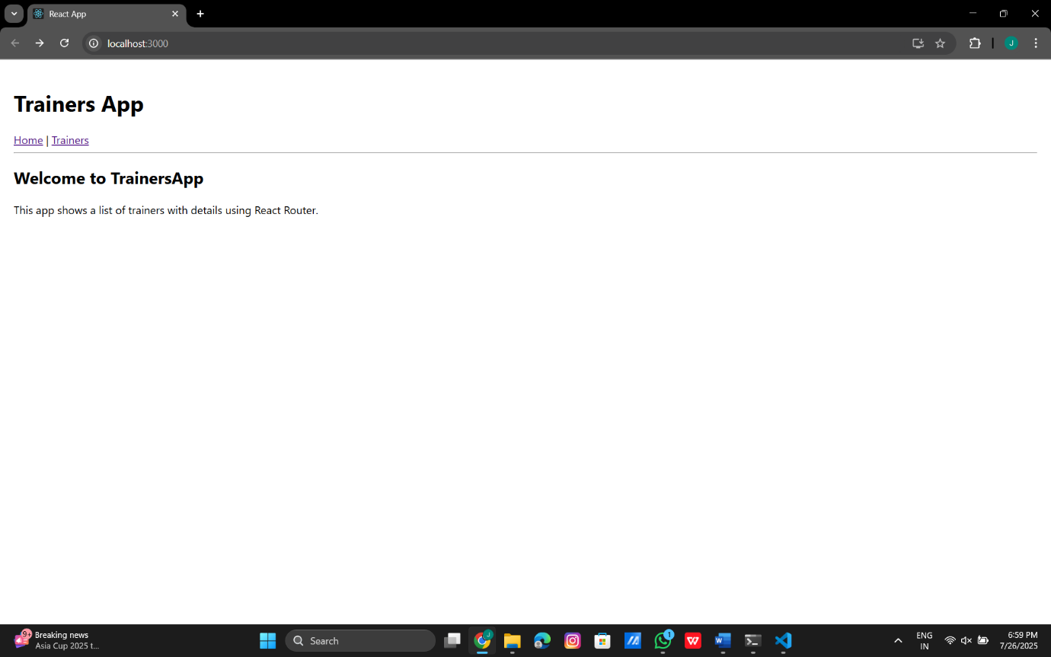

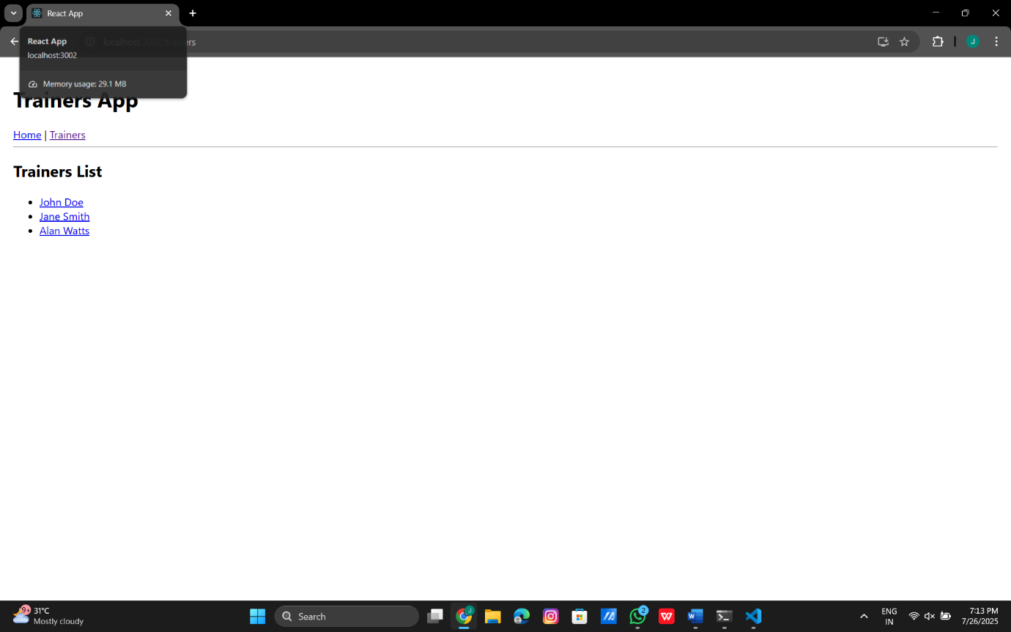
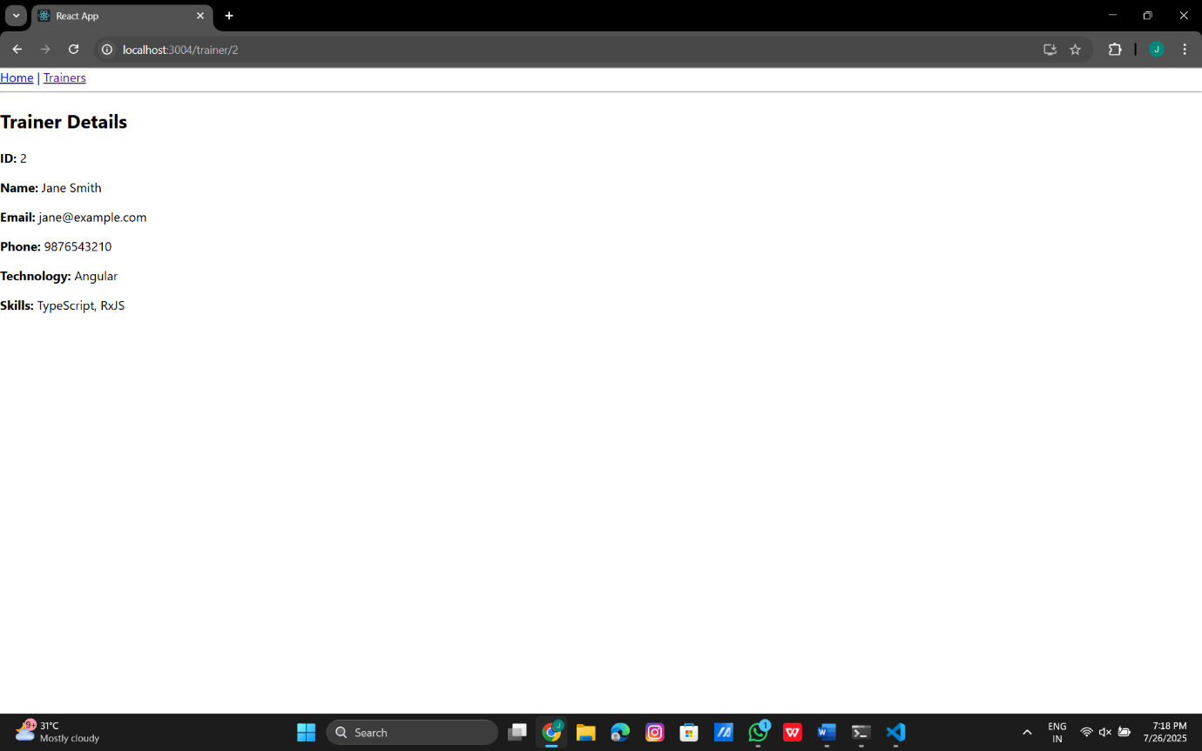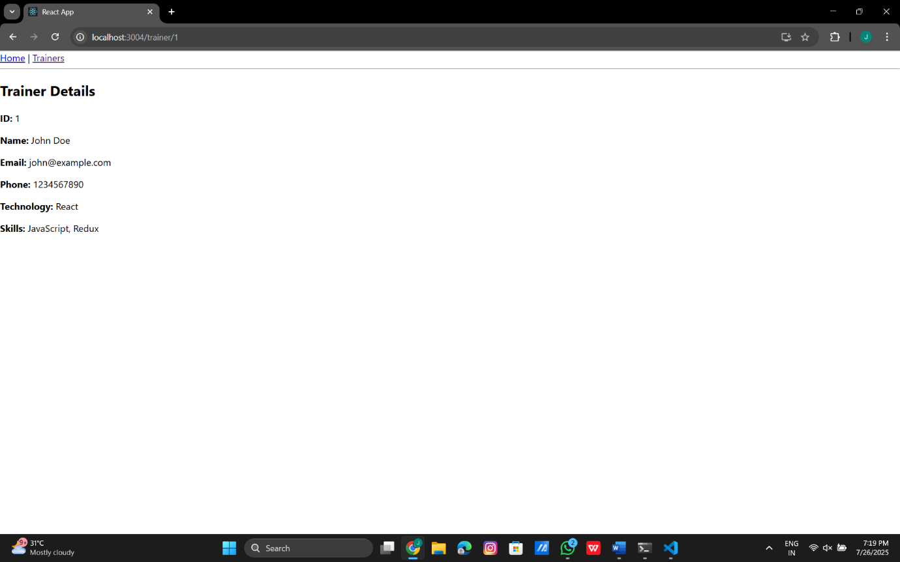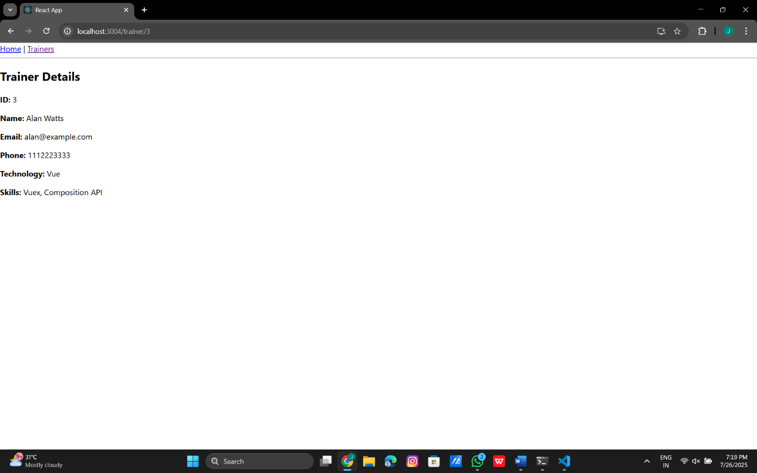

7.ReactJs
OnlineShopping.js:
import React from 'react';
import Cart from './Cart';
class OnlineShopping extends React.Component {
render() {
const items = [
{ itemname: "Laptop", price: 50000 },
{ itemname: "Headphones", price: 2000 },
{ itemname: "Keyboard", price: 1000 },
{ itemname: "Mouse", price: 700 },
{ itemname: "Monitor", price: 12000 }
];
return (
<div>
<h2>Available Items</h2>
{items.map((item, index) => (
<Cart key={index} itemname={item.itemname} price={item.price} />
))}
</div>
);
}
}
export default OnlineShopping;
Cart.js:
import React from 'react';
class Cart extends React.Component {
render() {
return (
<tr>
<td>{this.props.itemname}</td>
<td>{this.props.price}</td>
</tr>
);
}
}
export default Cart;

App.js:
import React from 'react';
import Cart from './Cart';
class App extends React.Component {
render() {
const items = [
{ itemname: 'Laptop', price: 80000 },
{ itemname: 'TV', price: 120000 },
{ itemname: 'Washing Machine', price: 50000 },
{ itemname: 'Mobile', price: 30000 },
{ itemname: 'Fridge', price: 70000 }
];
return (
<div style={{ textAlign: 'center', color: 'green' }}>
<h2>Items Ordered :</h2>
<table
style={{
margin: '0 auto',
borderCollapse: 'collapse',
width: '300px',
border: '1px solid gray'
}}
>
<thead>
<tr>
<th style={{ border: '1px solid gray', padding: '8px' }}>Name</th>
<th style={{ border: '1px solid gray', padding: '8px' }}>Price</th>
</tr>
</thead>
<tbody>
{items.map((item, index) => (
<Cart key={index} itemname={item.itemname} price={item.price} />
))}
</tbody>
</table>
</div>
);
}
}
export default App;

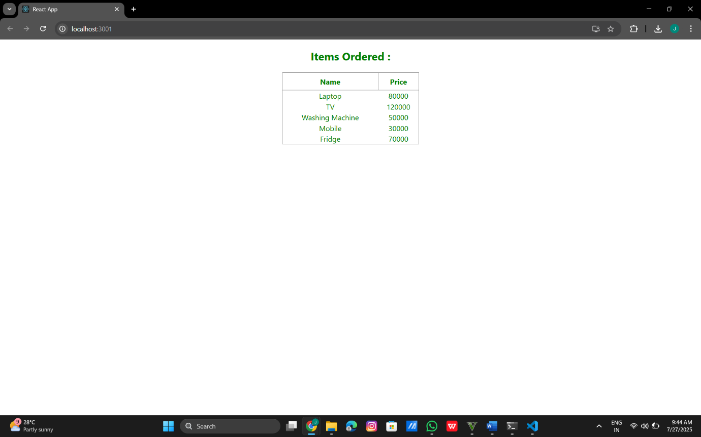

8.ReactJs
CountPeople.js:
import React from "react";
class CountPeople extends React.Component {
constructor(props) {
super(props);
this.state = {
entryCount: 0,
exitCount: 0
};
}
updateEntry = () => {
this.setState((prevState) => ({
entryCount: prevState.entryCount + 1
}));
};
updateExit = () => {
this.setState((prevState) => ({
exitCount: prevState.exitCount + 1
}));
};
render() {
return (
<div>
<h2>People Counter</h2>
<p>Entered: {this.state.entryCount}</p>
<p>Exited: {this.state.exitCount}</p>
<button onClick={this.updateEntry}>Login</button>
<button onClick={this.updateExit}>Exit</button>
</div>
);
}
}
export default CountPeople;
App.js:
import React from "react";
import "./App.css";
import CountPeople from "./CountPeople";
function App() {
return (
<div className="App">
<CountPeople />
</div>
);
}
export default App;
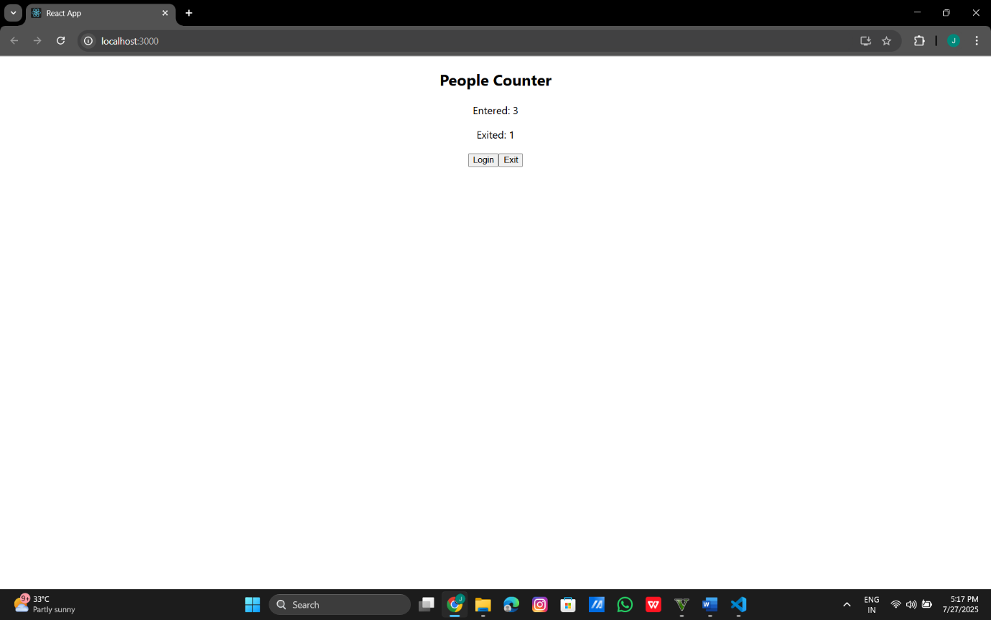

9.ReactJS
ListofPlayers.js:
import React from 'react';
const players = [
{ name: 'Virat', score: 100 },
{ name: 'Rohit', score: 60 },
{ name: 'Rahul', score: 40 },
{ name: 'Bumrah', score: 90 },
{ name: 'Shami', score: 70 },
{ name: 'Ashwin', score: 66 },
{ name: 'Gill', score: 95 },
{ name: 'Pant', score: 35 },
{ name: 'Jadeja', score: 78 },
{ name: 'Surya', score: 50 },
{ name: 'Kuldeep', score: 80 }
];
const ListofPlayers = () => {
// Use map to display all players
const allPlayers = players.map((player, index) => (
<li key={index}>{player.name} - {player.score}</li>
));
const lowScorers = players.filter(p => p.score < 70).map((p, i) => (
<li key={i}>{p.name} - {p.score}</li>
));
return (
<div>
<h3>All Players</h3>
<ul>{allPlayers}</ul>
<h3>Players with score below 70</h3>
<ul>{lowScorers}</ul>
</div>
);
};
export default ListofPlayers;
IndianPlayers.js:
import React from "react";
const IndianPlayers = () => {
// Array of Odd Players
const oddPlayers = ["Sachin1", "Virat3", "Yuvaraj5"];
// Array of Even Players
const evenPlayers = ["Dhoni2", "Rohit4", "Raina6"];
const [first, third, fifth] = oddPlayers;
const [second, fourth, sixth] = evenPlayers;
const t20Players = [
"Mr. First Player",
"Mr. Second Player",
"Mr. Third Player"
];
const ranjiPlayers = [
"Mr. Fourth Player",
"Mr. Fifth Player",
"Mr. Sixth Player"
];
const mergedPlayers = [...t20Players, ...ranjiPlayers];
return (
<div>
<h2>Odd Players</h2>
<ul>
<li>First : {first}</li>
<li>Third : {third}</li>
<li>Fifth : {fifth}</li>
</ul>
<h2>Even Players</h2>
<ul>
<li>Second : {second}</li>
<li>Fourth : {fourth}</li>
<li>Sixth : {sixth}</li>
</ul>
<h2>List of Indian Players Merged:</h2>
<ul>
{mergedPlayers.map((player, index) => (
<li key={index}>{player}</li>
))}
</ul>
</div>
);
};
export default IndianPlayers;
App.js:
import React from "react";
import "./App.css";
import IndianPlayers from "./IndianPlayers";
function App() {
return (
<div className="App">
<IndianPlayers />
</div>
);
}
export default App;

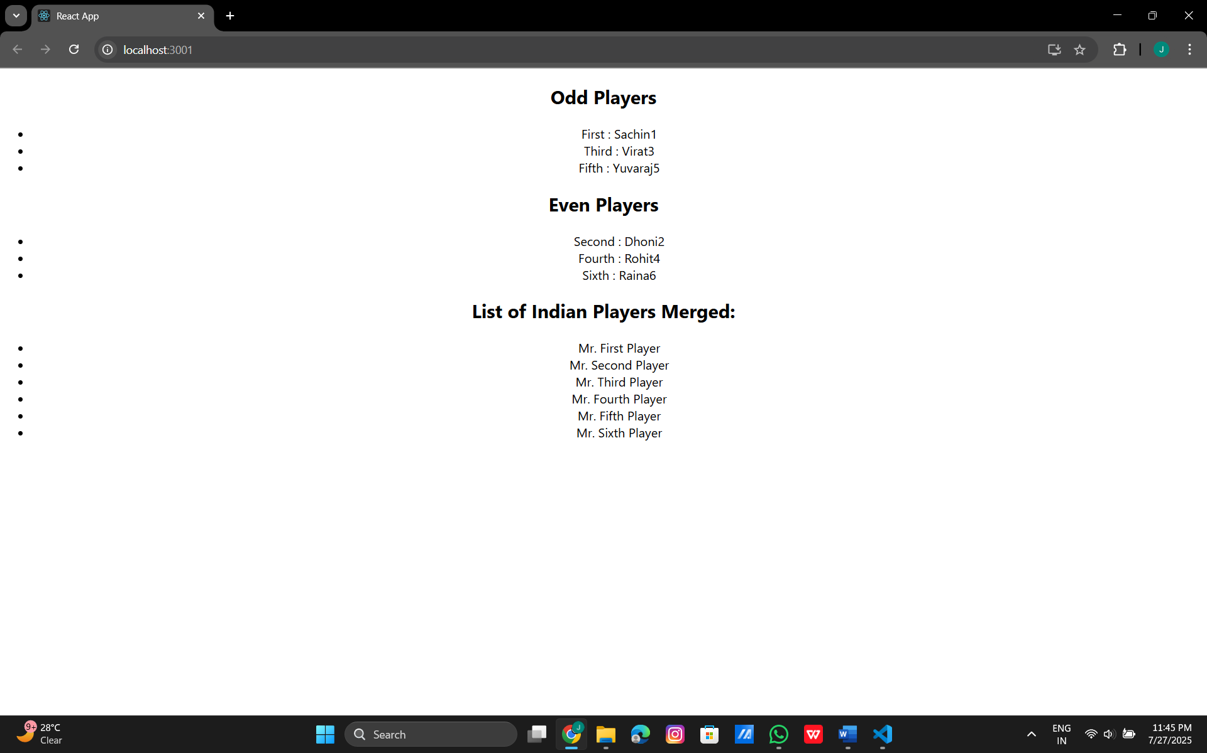
10.React.js
App.js:
import React from "react";
import "./App.css";
function App() {
const office = {
name: "Cognizant",
rent: 50000,
address: "Hyderabad",
image: "https://via.placeholder.com/400x250.png?text=DBS+Office+Space"
};
const rentStyle = {
color: office.rent < 60000 ? "red" : "green",
fontWeight: "bold"
};
const headingStyle = {
fontWeight: "bold",
marginBottom: "20px"
};
return (
<div className="App" style={{ padding: "20px" }}>
<h1 style={headingStyle}>Office Space , at Affordable Range</h1>
<img
src={office.image}
alt="Office Space"
style={{ width: "400px", height: "250px", marginBottom: "20px" }}
/>
<h2>Name: {office.name}</h2>
<p style={rentStyle}>Rent: Rs. {office.rent}</p>
<p>
<strong>Address:</strong> {office.address}
</p>
</div>
);
}
export default App;
